

**Solution Architecture Design**

**Patient Community Health**

Version: v0.06

# Document Control

## Document Details

|  |  |
| --- | --- |
| **Deliverable Name** | SAD – Patient Community Health |
| **Deliverable Number** | SAD01 |
| **Submitted by** | Samin Karim |
| **Author / Position** | Samin Karim |
| **Owner** | Samin Karim |

## Revision History

| **Date** | **Version** | **Description** | **Author** |
| --- | --- | --- | --- |
| 30/7/2014 | 0.04 | Initial draft | S. Karim |
| 12/3/2016 | 0.05 | Revised for RMIT student project | S. Karim |
|  |  |  |  |

## Document Approval

| **Name / Title** | **Role** | **Signature** | **Date** |
| --- | --- | --- | --- |
| S. Karim | Designer |  |  |
|  |  |  |  |
|  |  |  |  |
|  |  |  |  |
|  |  |  |  |
|  |  |  |  |

## Stakeholder Management

| **Name / Title** | **Interest** | **Review comments** | **Date** |
| --- | --- | --- | --- |
|  |  |  |  |
|  |  |  |  |
|  |  |  |  |
|  |  |  |  |
|  |  |  |  |
|  |  |  |  |
|  |  |  |  |
|  |  |  |  |
|  |  |  |  |
|  |  |  |  |
|  |  |  |  |

## Abbreviations and Terminology

| **Abbreviation** | **Definition** |
| --- | --- |
| A&E | Accidents & Emergency |
| ACCESS | Single point of Access for Community health and acute ambulatory services (Part of Patient Referral programme at Peninsula Health Hospital |
| A&P | Assessment and Plans |
| AEHRC | Australian e-Health Research Centre (Division of CSIRO) |
| CDS | Cardiac Depression Scale |
| CDA | Clinical Data Architecture |
| CDM | Chronic Disease Management |
| CHF | Congestive heart failure (CHF) or congestive cardiac failure (CCF), occurs when the heart is unable to provide sufficient pump action to maintain blood flow to meet the needs of the body |
| CHAMPION | CardioMEMS Heart Sensor which allows monitoring of pressure in NYHA Class III Heart Failure Patients |
| CHF - RP | Chronic Heart Failure Rehabilitation Program |
| CHC Services | Community Health Cardiac Services |
| CCU | Coronary Care Unit |
| CH | Community Health |
| CTAC | Clinical Trial Advisory Committee |
| EIiCD | Early Intervention in Chronic Disease |
| GP | General Practitioner |
| GCP | Good Clinical Practice |
| Healthlink | Healthink is Australia’s largest Secure Messaging Network and is a standards compliant product providing clinical practices with the capability to both send and receive messages with Health Care providers. |
| HIS | Hospital Information System |
| HL7 | Health Level Seven (HL7) is a standard series of predefined logical formulas for packaging healthcare data in the form of messages to be transmitted among computer systems. |
| KPI | Key Performance Indicators |
| ICD-10 | International Classification of Diseases (ICD) is the standard diagnostic tool for epidemiology, health management and clinical purposes. ICD-10 is the 10th revision. |
| MLHFQ | Quality of Life as measured by Minnesota Living with Heart Failure Questionnaire |
| MOC | Model of Care |
| MOP | Manual of Operating Procedures |
| NeHTA | National eHealth Transition Authority |
| NYHA | New York Heart Association (NYHA) Heart Failure Classification |
| PH | Peninsula Health |
| PCEHR | Personally Controlled Electronic Health Record - Federal Govt. initiative to build electronic health record of individuals that can be accessed by the patient, GPs, ambo staff. (Process managed by NeHTA) |
| PO | Project Officer |
| POC | Proof of Concept |
| ROI | Return on Investment |
| SAE | serious adverse event |
| SOB | Shortness of breath |
| SHER | Shared Health Electronic Record |
| SDLC | Software Development Life Cycle |
| S&S | Signs and Symptoms |
| QOL | Quality Of Life |
| UML | Unified Modelling Language |

# Outstanding Items

|  |  |  |  |  |
| --- | --- | --- | --- | --- |
| **ID** | **Outstanding Item** | **Date Raised** | **Status** | **Responsible** |
| 1 | Details of administration screens: create new organisation, new provider | 30/3/2016 | Open | Samin |
|  | IDAM integration specification. Simple use of basic Azure AD IDAM. | 30/3/2016 | Open | Samin |
| 2 | New section to update and improve UX after UpWork project with Amir | 30/3/2016 | Open | Samin |
| 3 | New patient portal (mobile app) with basic features: Patient’s profile, provider messenger, health measurement recorder/viewer, care plan viewer and progress note editor. | 30/3/2016 | Open | Samin |
| 4 | New patient portal: addition of measurement device integration. First up: Moto 360 for POX, steps, and activity monitor. | 30/3/2016 | Open | Samin |
| 5 |  |  |  |  |

# Table of Contents

1 Document Control 1

1.1 Document Details 1

1.2 Revision History 2

1.3 Document Approval 2

1.4 Stakeholder Management 2

1.5 Abbreviations and Terminology 3

2 Outstanding Items 5

3 Table of Contents 6

3.1 List of Figures 9

3.2 List of Tables 10

4 Objectives of this Document 11

4.1 Audience 11

4.2 References 11

4.3 Product impacts 11

4.3.1 Product Atlas 12

5 Business Context 13

5.1 Business Context 13

5.2 Business Benefits 13

5.3 Requirements Analysis Summary 13

5.4 Current and Future State 14

5.4.1 Current State 14

5.4.2 Future State 14

5.5 Scope 14

5.5.1 In Scope 14

5.5.2 Out of Scope 14

6 Domain specific requirements 15

6.1 Compliance to standards 15

6.2 Regulatory requirements 15

6.3 Other details 15

7 Architecture 16

7.1 System Architecture 16

7.1.1 MVC Architecture 17

7.2 Integration Architecture (Web Services) 18

7.2.1 Sequences 18

7.2.2 Web Service Specifications 18

7.3 Mobile Application Architecture 20

7.3.1 API library 20

7.3.2 Mobile application platform 20

7.4 Deployment architecture 21

7.5 Multi-tenancy 22

7.5.1 Organisations, Providers and Clients 22

7.5.2 Organisation and Providers 23

7.5.3 Clients 23

7.6 Information Model 25

7.6.1 Client (Patient) demographics 25

7.6.2 Client (Patient) Measurement 26

7.6.3 Care Plans 26

7.6.4 Provider and Organisation 27

7.6.5 DB scripts 28

7.7 Application Flow 29

7.7.1 Process Flow 29

8 Use Cases 30

8.1 Use Cases Summary 30

8.2 Site / App Map 31

8.3 UX1 - General screen design and behaviour: Web site 31

8.3.1 UX remediation following Release 1 34

8.4 UC1 – System Administration: Organisation setup 35

8.4.1 Identity Provider (IDP) 35

8.4.2 Administration screens 35

8.5 UC2 – System Administration: Provider setup 36

8.6 UC3 – Client Registration 37

8.6.1 Step 1 – Client Search 38

8.6.2 Step 2 – Client Creation 39

8.6.3 Conditions 40

8.6.4 Triggers 40

8.6.5 Actors 41

8.6.6 Basic Flow of Events 42

8.6.7 Technical design reference 42

8.7 UC5 – Provider Login 46

8.7.1 Username and Password 46

8.7.2 Landing page: Client search 46

8.8 UC6 - Client Browser 48

8.9 UC7 – Client Details 49

8.9.1 Collapsed view of client details 49

8.9.2 Pull out menu showing client details 49

8.10 UC8 – Care Plans 51

8.10.1 Care Plan remediations 56

8.11 UC8A – Care Plan List 58

8.12 UC9 – Provider details 59

8.13 UC10 – Care team member portal 60

8.14 UC11 – Client portal 61

8.15 UC12 – Client Health Record 62

8.16 UC13 – Health Measurement 71

8.16.1 Manual entry from provider portal 71

8.17 UC14 – Health Analytics 77

8.18 UC15 – Consultation Notes 78

9 Non-Functional Requirements 80

9.1 Usability Requirements 80

9.2 Hardware Transition Considerations 81

9.3 Software Transition Considerations 81

9.4 Conversion Requirements 82

9.5 Security Requirements 82

9.6 Logging and Audit Requirements 83

9.7 Performance 83

9.7.1 Load 83

9.7.1 Volume 84

9.7.2 Stress 84

10 Acceptance Criteria 85

10.1 List 85

10.2 Analysis Checklist 85

11 Appendix 87

11.1 Appendix A: 87

11.2 Issues Log 87

## List of Figures

Figure 1 - Overall system architecture 16

Figure 2 – Deployment architecture 21

Figure 3 - Multi-tenanted environment 22

Figure 7 - Manage My Health database creation and update SQL scripts 28

Figure 8 - TODO Use Case Summary showing the users and systems being utilised 30

Figure 9 - App / Site Map 31

Figure 10 - The general screen design in condensed mode (left menu collapses). Note that the usual items remain the same size. Only difference is that it will be more visible (width-wise) for smaller screens 32

Figure 11 – Client demographic editor menu pull-out: desktop / tablet view 32

Figure 12 - UX remediations 34

Figure 13 - New Organisation 36

Figure 14 - Edit Practices 36

Figure 15 - New Provider 37

Figure 16 - Edit Practices 37

Figure 17 - If "New client" is selected from previous screen, then this screen is shown. User must start typing in the name (or other identifiable data, such as phone number) in the search box to start searching in real time (i.e. search results start appearing as user types) 38

Figure 18 - Screen shown when search query entered ("Steve" in the search box at top left). After space first space is entered, the "New Client" button will appear. If the client is not found in the search results, then provider can select "New CLient" to make a new client file 39

Figure 19 - New client screen. As the user fills in the fields, other similar patients are shown on the left menu that closely matches the client. User can click these clients if they want to use these patients, and they will be selected into the client palette. 40

Figure 20 - Provider login screen 46

Figure 21 - First screen upon login (landing page). Shows the previous clients, and search box to search for other clients. once the provider starts typing in the search client box, search query results and options to create new client files will be presented. Please refer to section 9.6.1 for the process. 47

Figure 22 - Client Browser (from developed version). Also shows real-time filter at top right. When user types search term, the client list (displayed as tiles) will automatically filter 48

Figure 23 - Client selected in palette, and left hand side menu collapsed. User selects the 3 horizontal bar icon on top left, o swipes from left to right, to pull out the menu. 49

Figure 24 - New client screen. Once form above is filled in and “Create Client” is selected, the above screen will be shown where the patient is created. The undo button () will be available for 15 seconds after initial creation to reverse the client creation if the user made a mistake in creating this new file, or simply wishes to undo the process. 50

Figure 25 - The Reasons page of the care plan. 51

Figure 26 - Admin page of the care plan 52

Figure 27 - Plans page of the care plan. Users can add and delete action steps, care team members, goals, specify progress notes, and reminders 53

Figure 30 - Example measurement dialog box (for weight / BMI entry) 75

## List of Tables

Table 1 – Document References 11

Table 2 - Web services for Manage My Health to eTP Web integration 18

Table 3 Use Case Summary 30

Table 4 Security requirements 83

# Objectives of this Document

This document is a functional specification that describes the requested behaviour of the proposed software system. The documentation describes what is needed by the system user as well as requested properties of inputs and outputs. A functional specification is the technical response onto a matching requirements document (the requirements traceability matrix). Thus it picks up the results of the requirements analysis stage.

This document aims to achieve consensus on functionality between stakeholders, and to choose the solution option that represents the best cost-benefit profile.

## Audience

Overall, the document aims to inform the following audience:

1. Make the **developers** to know what to build
2. Make the **testers** to know what tests to run
3. Make **stakeholders** to know what they are getting

<List any other audience members as appropriate>

## References

The following documents and repositories must be referred to gain clarification and understand details not described in this FDS document. In particular the requirements traceability matrix and the ALM contain the details of overall requirements expressed as user stories.

| **Document / Repository** | **Description** | **Version** |
| --- | --- | --- |
|  |  |  |
|  |  |  |
|  |  |  |
|  |  |  |

Table 1 – Document References

## Product impacts

This section describes a checklist for the impact that the functional design has on the system. The below notes are a summary of those recorded in the product atlas in section 4.3.1 below.

| **Impacted Area** | **Comments** |
| --- | --- |
|  |  |
|  |  |
|  |  |
|  |  |
|  |  |

### Product Atlas

The following “product atlas’” outlines the features of products. Impacted areas should be marked in these embedded documents, and saved back into the document.

| **Product** | **Atlas** | **Notes** |
| --- | --- | --- |
|  |  |  |
|  |  |  |
|  |  |  |
|  |  |  |
|  |  |  |
|  |  |  |
|  |  |  |

# Business Context

## Business Context

## Business Benefits

Please refer to the BRD document for details.

## Requirements Analysis Summary

Please refer to the BRD document for details.

|  |  |  |  |
| --- | --- | --- | --- |
| **High-Level Requirements** | |  | |
| A | Definition of broad category requirements |  |
| B |  |  |
| C |  |  |
| D |  |  |
| **Detailed Requirements** | | |
| **<Broad Category – In ALM will be at Epic level>** | | |
| A.1 | Ability for <USER> to do <X> |  |
| A.2 | Etc. |  |

## Current and Future State

### Current State

### Future State

## Scope

### In Scope

| ID | In Scope item | Priority |
| --- | --- | --- |
|  |  |  |
|  |  |  |
|  |  |  |

### Out of Scope

| ID | Out of Scope item |
| --- | --- |
|  |  |
|  |  |
|  |  |

### 

# Domain specific requirements

This section lists all the compliance, regulatory and other requirements specific to the proposed system.

## Compliance to standards

N/A

## Regulatory requirements

* Refer to BRD, section L item 6: "Data must be stored on Australian servers”

## Other details

N/A

# Architecture

This section provides an overview of the solution, and includes:

* **System Architecture**: How the system is built, showing the components and how they integrate
* **Integration Architecture**: Detailed protocols and data exchange between components are shown in an integration architecture, such as web service specifications
* **Deployment Architecture**:The deployment of the systems on infrastructure
* **Information Model**: Any data model changes required from this FDS will be summarised in this section
* **Application Flow**: The overall application flow is described (either diagrammatically or in words)

## System Architecture

The diagram (Figure 1, below) illustrates the system components and how they integrate. Main points are:

* System is web-based
* Web-based interface allows use on desktop with a mouse
* Can also be used via tablet computer using tap, swipe and pinch gestures
* Both desktop and tablet experiences are possible with the same interface
* The same screen definitions for Tablet and Web will be shared. This might be enabled by using HTML5 screens?
* Mobile app will be a different application altogether and hence a different set of screens.
* An app (developed in HTML5) will be derived from the interface code base to enable faster user experience on a future-developed app for the system. For the app, local database caching on the tablet platform will be implemented (subject to patient data privacy and duty of care/clinical safety requirements)



Figure 1 - Overall system architecture

In all deployments – desktop web, or mobile/tablet app – the data mode and application logic must be separate from the HTML5 code. This way we can take the HTML5 code and use it across both deployments without any change to the presentation layer.

### MVC Architecture

The system will be built on an MVC architecture – Model-View-Controller. MVC architectures are essentially a structured way to organise the components of a system that consist of:

* A presentation layer: The “View”
* The data layer: The “Model”
* The application logic layer: The “Controller”

The main abstraction occurs around the presentation layer (view) and data layer (model). However, application logic should also be abstracted.

**Data Layer**

We will contain the model in a separate library package which abstracts the detail around data access and manipulation. Within the application logic layer, or the presentation layer itself, there should be no embedding of low-level code to access the data. For example, to access patient details, a SOAP (XML) or RESTful (JSON) web service is called. However, the code for accessing this function will be hidden behind a function called getPatientFile with simple parameters to identify the patient (name, address, DOB) passed as inputs. The response can come back in an XML file, but the protocol is abstracted – if we choose to move to, say, a WebAPI protocol in future, the function call will be unchanged.

**Application Logic Layer**

Any processing of data that occurs external to the data model should also be abstracted into a separate library (the “Controller”). This part of the system will take data and inputs from the user and present them.

For example, some data mining functionality that fuses different health data together would appear in this layer. As with the above example, we would place this in an abstracted library. For the data mining, the inputs might be several data sets, and the output would be a subset of data where “confluence” is detected based on intelligent or semi-intelligent algorithms. Output would be displayed on the presentation layer.

Similarly the PGS “fluents” mechanism would be abstracted in this layer, but the output would be directed back to the data model itself.

**Presentation Layer**

The presentation layer deals entirely in the UI space. How data is presented, and the visual appearance is covered here. It is vital that no data model or application logic (as described above) should appear here. For an HTML5-based application, we must make sure that there is no embedded JavaScript in the HTML5 code (JavaScript should be kept in separate Jscript files in the application logic layer), and definitely no SQL scripts!

## Integration Architecture (Web Services)

As shown in the system architecture in Figure 1, there are several web services required for the components to pass data between each other.

TODO

### Sequences

### Web Service Specifications

This section describes the web services that are required to be built and exposed from the various systems:

#### Webs service group 1

| ID | Web Service | Description | Parameters | Return |
| --- | --- | --- | --- | --- |
|  |  |  |  |  |
|  |  |  |  |  |

Table 2 - Web services for Manage My Health to eTP Web integration

#### XML / XSD / WSDL definitions

The web services for integrating Manage My health (MMH) with eTP web (MEPACS system), and MMH with MDA (clinical audit tool) are defined by the following specification files. Please refer to the above sections for a description of how these services operate.

| Web Service | CAMed[1] file | XSD | Example XML | WSDL |
| --- | --- | --- | --- | --- |
| Manage My Health to eTP Web (push) | | | | |
|  |  |  |  |  |
|  |  |  |  |  |
|  |  |  |  |  |
|  | | | | |
|  |  |  |  |  |
|  |  |  |  |  |
|  |  |  |  |  |
|  | | | | |
|  |  |  |  |  |
|  |  |  |  |  |

## Mobile Application Architecture

### API library

The mobile application must be built through the separation and abstraction of common features and data access to the NCH application server through an application API. This API will reside in a library (in Android, this is a “jar” file) or equivalent iOS library (for iOS app) that contains classes that allow the app to call upon commonly used features:

* Authentication (login) – including the token-based login protocol
* Access to patient demographics
* Access to patient clinical data
* Etc.

Rather than “hard-coding” the above example features throughout the mobile application and web site, they must be abstracted behind re-usable Java classes. This will enable future development of mobile applications using this abstracted API, thus allowing rapid application development and deployment for future use cases.

Refer to Figure 1 for illustration of the solution integration.

### Mobile application platform

For the trial, the mobile application architecture must be built as a native application that displays data using natively built libraries. Screens must be locally defined, and only content (data and multimedia) is sourced from web services.

Apart from a better, more fluid user experience, this design requirement is important to allow acceptance for the Apple version, which has a far more stringent approval process.

**For this project, the mobile app must be defined as native Android and iOS screens.**

## Deployment architecture

The system, illustrated in Figure 2, will be deployed across multiple environments for the various components and areas:

* **TODO**



Figure 2 – Deployment architecture

## Multi-tenancy

The NCH application operates as a multi-tenanted environment. This means that multiple segregated areas will exist for each customer, such that each customer (or tenant) cannot view or manipulate data and configurations from another customer.

Multi-tenancy can be economical because software development and maintenance costs are shared. It can be contrasted with single-tenancy, an architecture in which each customer has their own software instance and may be given access to code. With a multi-tenancy architecture, the provider only has to make updates once. With a single-tenancy architecture, the provider has to touch multiple instances of the software in order to make updates.

A very useful architectural description of multi-tenancy can be found in this MSDN article: <https://msdn.microsoft.com/en-us/library/aa479086.aspx>

### Organisations, Providers and Clients

Multi-tenancy is divided along lines of:

* **Organisations**: The organisations that contain a hierarchy of providers (clinicians / staff)
* **Providers**: The staff within an organisation. One provider is nominated “Manager”, and has admin rights and access permission on all other providers and patients
* **Clients**: Otherwise known as “Patients”, clients are initially assigned to the provider that created their file in the system. Until the client is served by another provider in the organisation, the information stored in the client file cannot be viewed by anyone else. The access rights on a client are a critical aspect of the system and must be managed carefully



Figure 3 - Multi-tenanted environment

The diagram shown in Figure 3 illustrates the idea.

* There are 2 organisations: Org A and Org B. Each exists as a separate tenant
* Org A and B both share a provider: “Provider A.2”.
  + This is possible since one provider (staff) could be employed by two separate organisations.
  + In each organisation, they will have separate settings, but will have access to the same set of patients.
  + So for Provider, Client B.3 is a new client created within Org B, and Client A.3 and Client A.2 are still accessible within the Provider A.2 context since Provider A.2 created these client files within Org A.
* Client A.2 has been created by Provider A.1, but was served by Provider A.2, and hence he has access to the Client A.2.
  + Similarly Client A.2 was seen by Provider B.1 who can also see the Client A.2 file. However in this case, Provider B.1 must ask for consent from Client A.2 before accessing the data since he/she is from another organisation (Org B)

### Organisation and Providers

Organisations are created first, and providers are assigned to one or more organisation. An organisation has basic information stored about it (described in section 7.6.4).

At creation time, an organisation does not need to have a provider assigned to it, however when a provider is first assigned to an organisation they are informed that they are the admin provider and has admin rights to change settings etc. This simplifies the organisation creation process (i.e. you do not need to have a provider created first).

Upon creation, a provider must be assigned to at least one organisation.

Providers within an organisation can view each others’ provider files.

### Clients

When a client file is created, they are assigned to the provider that created them. Initially the system does not allow creation of a new client file. Rather, it will ask the provider to search for a client in the system.

* If a client file is not found, then a new client file can be created. This prevents duplicate client files from being created.
* Note that the client search capability extends to clients from all organisations, but only minimal information is returned in the search query: full name, date of birth, photo ID (if available) and Medicare / IHI number. Address and phone number is not returned to protect the client’s contact information.
* Clients that were initially registered in the provider’s employing organisation(s), are highlighted marked accordingly (e.g. highlighted with yellow background).
* Clients that were registered by the provider are shown in full in the search results (using the “NominatedProviderID” field in the client file, see section 7.6.1).

Providers within the same organisation can only see a client file if accessed during a consultation (service) and consent is provided by the client. Consent is recorded very simply with a check box (“Client consents to accessing their file?”).

If a provider from *another organisation* serves a client initially created elsewhere (such as for Client A.2 in the example above), then the patient will be informed via email that there client file has been accessed in the new organisation, and that they have consented to it. Consider Client A.2 being accessed by Provider B.1:

**Hi Client A.2,**Please be aware that you have consented **Provider B.1** from **Organisation B at [ORG B ADDRESS]** to access your file during a consultation today ([DATE-TIME]).   
Please contact [ORGANISATION B PHONE NUMBER] if you have any queries.

Regards,

***NCH portal team***

## Information Model

The data model for various aspects of the system:

* Patient data
* Heath records
* Health measurements
* “Fluents” – automatically generated chronological data fusion tables
* Care plan

### Client (Patient) demographics

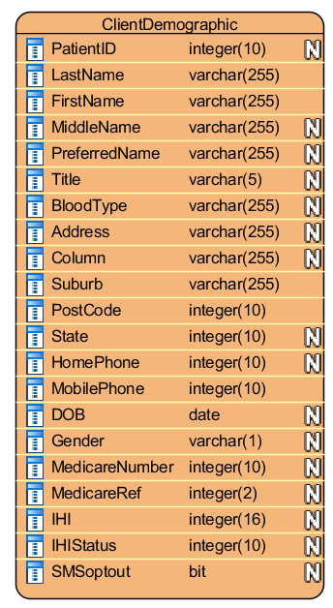

### Client (Patient) Measurement

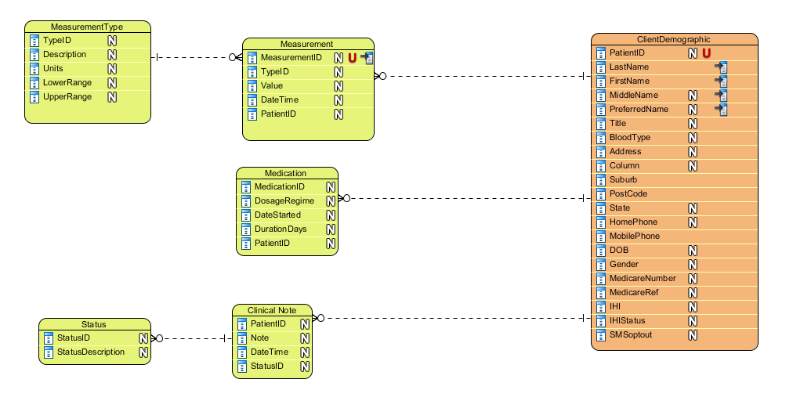

### Care Plans

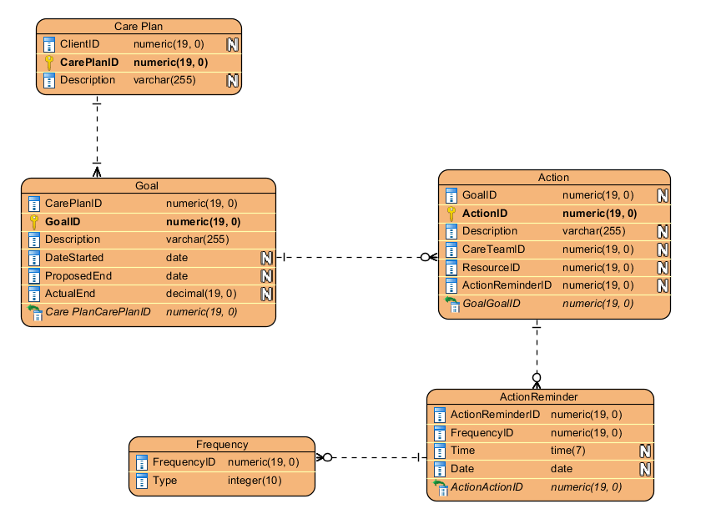

Care Plan

* ClientID is the client the care plan relates to.

Action

* CareTeamID is the provider (ProviderID) responsible for the action. This can be either a provider in the system, or another provider not registered in the system
* If the CareTeamID is not a provider, then it is stored as a basic provider not associated with any organisation

Goal

Action Reminder

Frequency

### Provider and Organisation

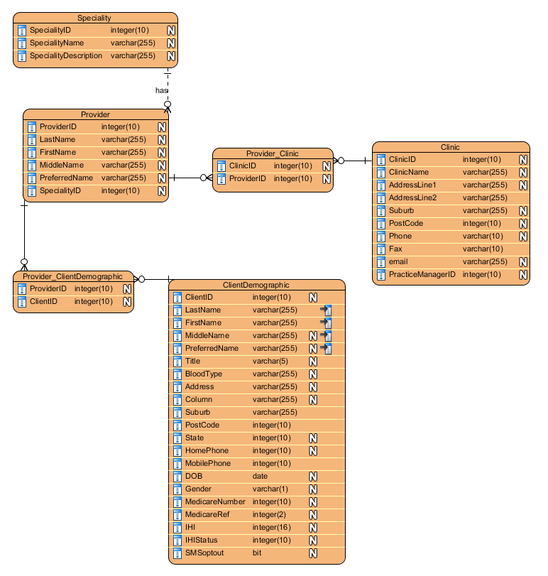

### DB scripts

The following scripts should be used to create and update Manage My Health database tables, as described in the preceding subsection.

Figure 4 - Manage My Health database creation and update SQL scripts

| DB script | Notes |
| --- | --- |
|  |  |
|  |  |
|  |  |
|  |  |

## Application Flow

This section describes the application flow required from the application. Simple screen mock-ups can be included in the screens section below.

The following sections in section 8 provide details around the components of the application architecture flow described above:

* **Use case definition**: The details of the particular use case
* **Screens**: The user interface displays of the application. Includes basic and interactive forms, pop-up messages and dialogs.
* **Decision Logic and Process Steps**: Processing and decisions made by the application
* **Commands**: Specific commands that the user can issue, usually by "tapping" a button or list selection.

### Process Flow

The following workflows illustrate the important application processes relevant to the solution.

# Use Cases

This section describes the use cases and the associated software artefacts such as screens, decision logic and commands, that are required.

|  |  |
| --- | --- |
| Description of Use case Category | Use Cases Identified |
| Patient Registration Process and profile modification | UC-1, UC-35, UC-6 |
| Etc. |  |

## Use Cases Summary

| **Ref** | **Description** | **Priority** | **Code** | **Module** | **Functional Changes** |
| --- | --- | --- | --- | --- | --- |
| UX-1 | General screen design and behaviour: Web site | High |  |  |  |
|  |  |  |  |  |  |
|  |  |  |  |  |  |
|  |  |  |  |  |  |
|  |  |  |  |  |  |
|  |  |  |  |  |  |
|  |  |  |  |  |  |
|  |  |  |  |  |  |
|  |  |  |  |  |  |
|  |  |  |  |  |  |

Table 3 Use Case Summary

Figure 5 - TODO Use Case Summary showing the users and systems being utilised

## Site / App Map

The following is a summary of the general screen flows in the application and web site.



Figure 6 - App / Site Map

* The site / app has the one entry point: the login page. Both Admin user and Provider user logs in form this screen
* Admin user sees a simple screen for creating and editing providers and organisations
* Provider user logs in, and must first search for a client before they can do anything
  + Search for a client first
  + If desired client is found, user presses the icon, which brings the client to the “palette”
  + If one is not found then an option will be provided to create a new one
  + Health record, health measurements and care plans can be accessed for each client

## UX1 - General screen design and behaviour: Web site

In this section we describe the general screen design and look-and-feel modifications required of the **desktop view of the web site** from the various systems that are required for this project.



Figure 7 - The general screen design in condensed mode (left menu collapses). Note that the usual items remain the same size. Only difference is that it will be more visible (width-wise) for smaller screens



Figure 8 – Client demographic editor menu pull-out: desktop / tablet view

This screen shows the client demographic editor, which pulls out form the left with a swipe from left to right, or tapping the “  ” icon. Swiping from right to left, or tapping the “  ” icon again will return the pull out menu back to the condensed view of Figure 7.

In this screen, the provider can edit the patient’s demographic details. All changes are automatically saved to the client’s file. If the “  “ icon is pressed, then the changes are “undone” and not saved.

Main points to note:

| ID | Item / Feature | Description |
| --- | --- | --- |
| 1 | Left menu (dark blue) | This menu is used to access high level functions of the system. Namely: accessing patient files, list of all currently active care plans (and creating new ones), health data mining, and management of appointments.  This menu can also be hidden by selecting the  icon. After clicking this, it will look like Figure 7. Clicking the icon again will revert back to Figure 8. |
| 2 | Top menu | This stays on the screen at all times. It contains links that are relevant for all scenarios:   * **Get Started**: A link that gives a quick tutorial about the system * **Notifications**: The inbox for messages sent to the active account. The number in orange indicates the number of recently received/unopened messages * **Search**: This is your standard google search capability that allows users to search terms across all staff and patients in their practice, as well as other non-user data (e.g. global documents) * **Date**: The current date * **“Dr. Clinical User”**: The user currently logged in. Clicking it will drop down a list of standard functions: Profile, Settings, Change User, Sign Out |
| 3 | Tiled structure | All interactive items in the screen appear as tiles. The user can click (or tap if on tablet/phone), and zooming in/out has the effect of enlarging or shrinking the tiles and the text/pictures in them.  When viewed in a tablet, the pinch gestures will have the zoom effect, whereas the swipe gestures will have the scroll effect (id there are more items below). This will be indicated by the “More …” text and arrow encouraging the user to scroll/swipe down to see what else there is. |
| 4 | “New Client” button | This initiates the new client screen and sequence, as detailed in section 8.6. |
| 5 | Search | The search text box, when tapped, will open the virtual keyboard (search view) in tablet mode and allow entry of free text. Hitting search will search in the current context of the screen. For example, if the user is in “Client list” mode, it will search based on client demographics (on all attributes – name, address etc.).  An advanced search can be accessed by long-pressing the search text box, or clicking “Advanced” next to the search box. This will open a detailed search pop-up with more attributes (TODO: Need to define this screen) |

### UX remediation following Release 1



Figure 9 - UX remediations

The following changes are needed to the UI screens delivered as part of Release 1 (Amir through Upwork):

| **ID** | **UX Change Description** | **UX area** |
| --- | --- | --- |
| 1 | Menu to come from the left side, as per standard menu UX experience for Android/iOS apps.  Animation to slide out from left smoothly. Use of hardware acceleration using appropriate platform specific UI platform (such as jQueryMobile, Appcelerator, etc.) should be used to improve UI. | Menu |
| 2 | Fix “Nomadic Care” logo fonts to be same size and higher resolution (see menu logo – which is same as the login screen logo) | Menu, Login screen |
| 3 | Background to be straight black | All screens |
| 4 | Screen transitions need to be rectified:   * Transition for going forwards should be screen swiping to the left. Example: after logging in, selecting a client, opening care plan. * When moving “backwards” to previous screen, screen transition needs to be swiping to the right. Example: When clicking “clients” screen from care plan screen, signing out and going back to login screen. * Animation needs to be improved: the transition is a bit jittery – particularly for Android version. Please use appropriate hardware acceleration library to access the device GPU | Page transitions |

## UC1 – System Administration: Organisation setup

### Identity Provider (IDP)

Before organisations, providers and clients can be created in the system, a suitable IDP must be selected and configured.

The following identity components need to be created:

1. **Organisation**: a care coordination centre, or a service provider centre/clinic that is part of a care plan (“care team member”)
2. **Provider**: A specific provider (e.g. “Dr. Smith”, cardiologist, part of organisation, “Eastern Cardiology”), including the care coordinator himself/herself. Basically, all the health professionals and service providers on a care plan, who all belong to one or more providers.
3. **Client**: The recipient of care. Multiple providers care for a client, and a client is associated with a specific care coordination centre (organisation)

A suitable IDP must be deployed, and configured on the server. Given the system is hosted on Azure, we can use Azure AD (Active Directory).

For more information about the organisation-provider-client hierarchical relationship, refer to the information model section, specifically section 7.6.4.

### Administration screens

A simple set of screens and functions to setup new organisation.

Setup includes the following:

* Organisation name, location, speciality
* Ability to edit existing organisations



Figure 10 - New Organisation



Figure 11 - Edit Practices

## UC2 – System Administration: Provider setup

A simple set of screens and functions to create a new provider.

Setup includes the following:

* Provider name, address, contact details, speciality
* Ability to edit existing providers

When a new provider is created, the system will send an email to the provider’s email address with a temporary password. This temporary password will only last for 12 hours.

Upon first login, the user will be asked to change the password.



Figure 12 - New Provider



Figure 13 - Edit Practices

## UC3 – Client Registration

Clients are created by providers. They search for the clients first before adding them. This ensures that duplicates are not created.

### Step 1 – Client Search

The first step is to search the portal for any pre-existing clients. If one does exists, then the system will force the provider to use that file and associate it with the provider (if not already).

If a patient is already selected (i.e. in the “palette”) then they can be seen in the left hand side pull out menu. This is viewable when

* “New client” is selected from client details screen (see section 8.9.2, “Pull out menu showing client details”).
* If provider has not selected a client previously, and needs to search for one / create one



Figure 14 - If "New client" is selected from previous screen, then this screen is shown. User must start typing in the name (or other identifiable data, such as phone number) in the search box to start searching in real time (i.e. search results start appearing as user types)

Once provider starts filling in details in the search box, a search query result will be show, plus a “New Client” button below the search results if the client matching the search query is not shown. The “New Client” button is not shown until the first name is entered (i.e. after the first space is entered).



Figure 15 - Screen shown when search query entered ("Steve" in the search box at top left). After space first space is entered, the "New Client" button will appear. If the client is not found in the search results, then provider can select "New CLient" to make a new client file

### Step 2 – Client Creation

If a patient is not found in step 1 (above), then user can select “New Client” button (in the screen above) and a new client can be created – which is associated to the provider. Note: The association is a many-to-many: a client can be associated to many providers, and a provider can be associated to many clients.



Figure 16 - New client screen. As the user fills in the fields, other similar patients are shown on the left menu that closely matches the client. User can click these clients if they want to use these patients, and they will be selected into the client palette.

Once the patient is created, the patient details can be viewed. This appears as a large pull out menu which can be further edited. Please refer to section 8.9 for details (“UC7 – Client Details”).

### Conditions

|  |  |
| --- | --- |
| **Pre-Conditions** | * Logged in as a provider * You cannot create a client file unless you are logged in as a provider in an organisation |
| **Success Post Conditions** | * New client created * OR, existing client found |
| **Failure Post Conditions** | Neither new client created nor existing client found. This will occur if no client exists, and provider decides not to create a new client file |

### Triggers

The system and environment conditions that trigger this use case.

|  |  |
| --- | --- |
| **Triggers** | * Client selected from “Previous Clients” list * Search query entered in “Client search” box |

### Actors

The actors (users) that are involved with the use case.

| **Actors** | **Explanation** |
| --- | --- |
| Provider | Registered provider, who has authority to create new patients |
| Client | Client who consults a provider, and who has a file in the system accessible by the provider who initially created the file. Note that other providers in the same organisation can access and add data to the client file, but not providers from other organisations. |
|  |  |

### Basic Flow of Events



### Technical design reference

N/A

A new database entity is required to map patients to providers. Please refer to information model for details (section 7.6).

#### **(DELETE / MOVE?)** NHSD API – National Health Service Directory

The NHSD is a live database of health service across Australia.

An API exists, and the details can be found here in this API directory.

<http://nhsd.data.com.au/NHSDDataAPIWebService/>

TODO: More details of SOAP/Rest web services needed

API

The following operations are supported. For a formal definition, please review the [**Service Description**](http://nhsd.data.com.au/NHSDDataAPIWebService/API.asmx?WSDL).

* [**GetCoverageAreaLocalitiesForSSID**](http://nhsd.data.com.au/NHSDDataAPIWebService/API.asmx?op=GetCoverageAreaLocalitiesForSSID)
* [**GetExpandedSiteData**](http://nhsd.data.com.au/NHSDDataAPIWebService/API.asmx?op=GetExpandedSiteData)
* [**GetPractitionerLanguagesSpoken**](http://nhsd.data.com.au/NHSDDataAPIWebService/API.asmx?op=GetPractitionerLanguagesSpoken)
* [**GetServiceLookupViaEnum**](http://nhsd.data.com.au/NHSDDataAPIWebService/API.asmx?op=GetServiceLookupViaEnum)
* [**GetSuburbList**](http://nhsd.data.com.au/NHSDDataAPIWebService/API.asmx?op=GetSuburbList)
* [**GetTelehealthEnabledServiceTypes**](http://nhsd.data.com.au/NHSDDataAPIWebService/API.asmx?op=GetTelehealthEnabledServiceTypes)
* [**GetVersion**](http://nhsd.data.com.au/NHSDDataAPIWebService/API.asmx?op=GetVersion)
* [**HSDGetLookupListViaEnum**](http://nhsd.data.com.au/NHSDDataAPIWebService/API.asmx?op=HSDGetLookupListViaEnum)
* [**SearchSiteResults**](http://nhsd.data.com.au/NHSDDataAPIWebService/API.asmx?op=SearchSiteResults)
* [**SiteSearch**](http://nhsd.data.com.au/NHSDDataAPIWebService/API.asmx?op=SiteSearch)
* [**TelehealthTest**](http://nhsd.data.com.au/NHSDDataAPIWebService/API.asmx?op=TelehealthTest)
* [**TestConnection**](http://nhsd.data.com.au/NHSDDataAPIWebService/API.asmx?op=TestConnection)
* [**TestMethod**](http://nhsd.data.com.au/NHSDDataAPIWebService/API.asmx?op=TestMethod)
* [**TestSearch**](http://nhsd.data.com.au/NHSDDataAPIWebService/API.asmx?op=TestSearch)
* [**TestSiteSearch**](http://nhsd.data.com.au/NHSDDataAPIWebService/API.asmx?op=TestSiteSearch)

Further details can be found here:

<http://docs.health.vic.gov.au/docs/doc/51851F53676E7893CA257CF6000AA9DB/$FILE/NSHD%20Guide%20-%20Governance%20and%20the%20use%20of%20NSHD%20data%20in%20Health%20Applications.docx>

## UC5 – Provider Login

### Username and Password



Figure 17 - Provider login screen

Providers log in using their username and password.

Usual processes for Forgot username or forgot password exist:

* Forgot username
  + If clicked, user will be asked for their name and date of birth, and other personally indentifiable data
  + The username (email address) will then be SMS’ed to their registered mobile number
* Forgot password
  + Username (email address) will be requested
  + Confirmation will be shown if user wants to resent password: “Do you want to reset your password?”
  + New temporary password will be emailed to the username (email address). If not actioned in 1 hour, the temporary password will revert to the original password
  + Upon initial login, user will be required to set a new password. Old passwords cannot be used, except for the recently changed one (i.e. if user happens to enter the same password they forgot!)

### Landing page: Client search

First screen is to search for a client (patient) if a file exists for the patient. This is to ensure duplicate files are not created (i.e. first search for existing file, THEN allow creation of a new file if one does not exist).



Figure 18 - First screen upon login (landing page). Shows the previous clients, and search box to search for other clients. once the provider starts typing in the search client box, search query results and options to create new client files will be presented. Please refer to section 8.6.1 for the process.

As per the usual client search and creation process, once the provider starts typing in the search client box, search query results and options to create new client files will be presented. Please refer to section 8.6.1 for the process.

## UC6 - Client Browser

From the provider login, all the clients can be viewed, and filtered using a real-time search function.

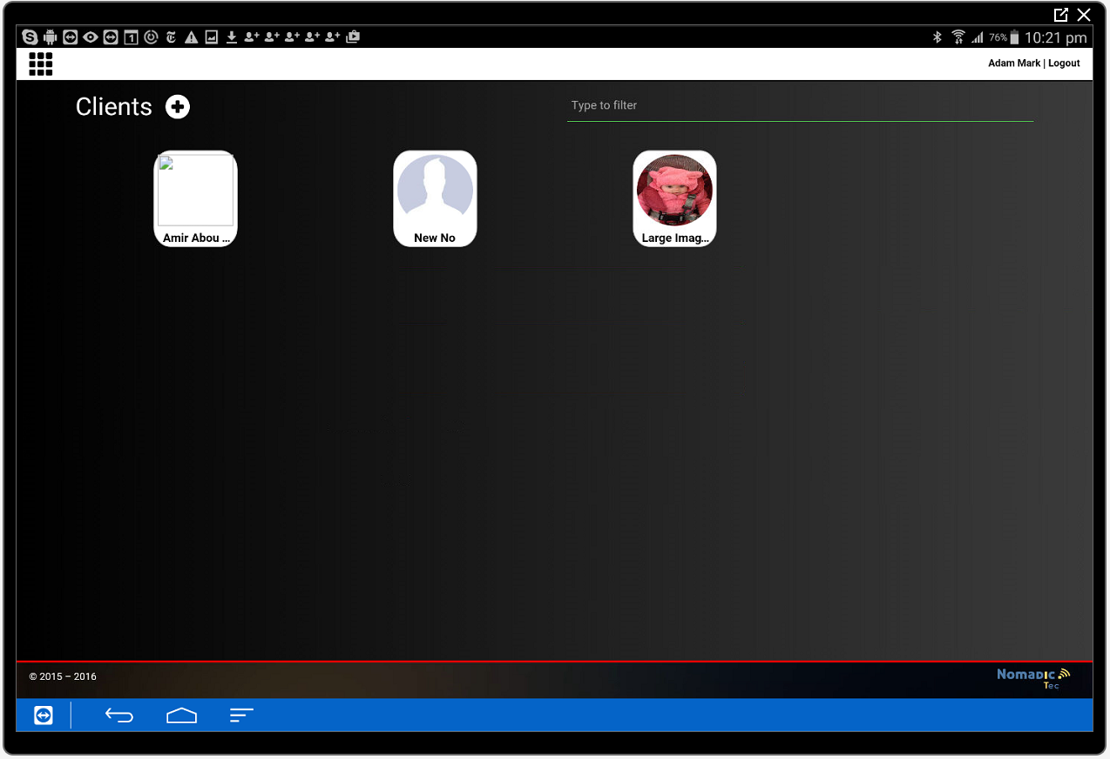

Figure 19 - Client Browser (from developed version). Also shows real-time filter at top right. When user types search term, the client list (displayed as tiles) will automatically filter

## UC7 – Client Details

The patient details are visible by pulling out the left menu, showing the details of the patient which can be edited and saved.

### Collapsed view of client details



Figure 20 - Client selected in palette, and left hand side menu collapsed. User selects the 3 horizontal bar icon on top left, o swipes from left to right, to pull out the menu.

### Pull out menu showing client details

If user swipes from left to right on the collapsed view shown above, the details are displayed and can be edited.

Edits will be saved instantly, but if the undo button is clicked the changes will be reverted to the previous values. Undo function is maintained to infinity edits on a 3 second time frame (i.e. every undo action will undo changes in the last 3 seconds).



Figure 21 - New client screen. Once form above is filled in and “Create Client” is selected, the above screen will be shown where the patient is created. The undo button () will be available for 15 seconds after initial creation to reverse the client creation if the user made a mistake in creating this new file, or simply wishes to undo the process.

## UC8 – Care Plans

Care plans are an integral component of the Nomadic Care portal that allows community/case workers to create and manage client care plans. The care plans are viewable and actionable by all actors (users):

* The provider who created the care plan can view and edit the care plan
* All providers in the organisation can only view the care plan
* Care team members can only view the care plan – but can add progress notes to the plan step they have been assigned to
* The patient can view the care plan and add progress notes

The care plan screens – modelled on the **SCTT form** structure used in community care centres in Australia - are divided into 3 sections

1. **Reason(s):** The overall purpose of the care plan
2. **Admin:** detals about the coordinator, case conference notes (initial meetings about the case), other considerations and other related / unrelated plans
3. **Plan:** Details of the plan itself, including required tasks, care team members needed, dates, progress notes



Figure 23 - Admin page of the care plan

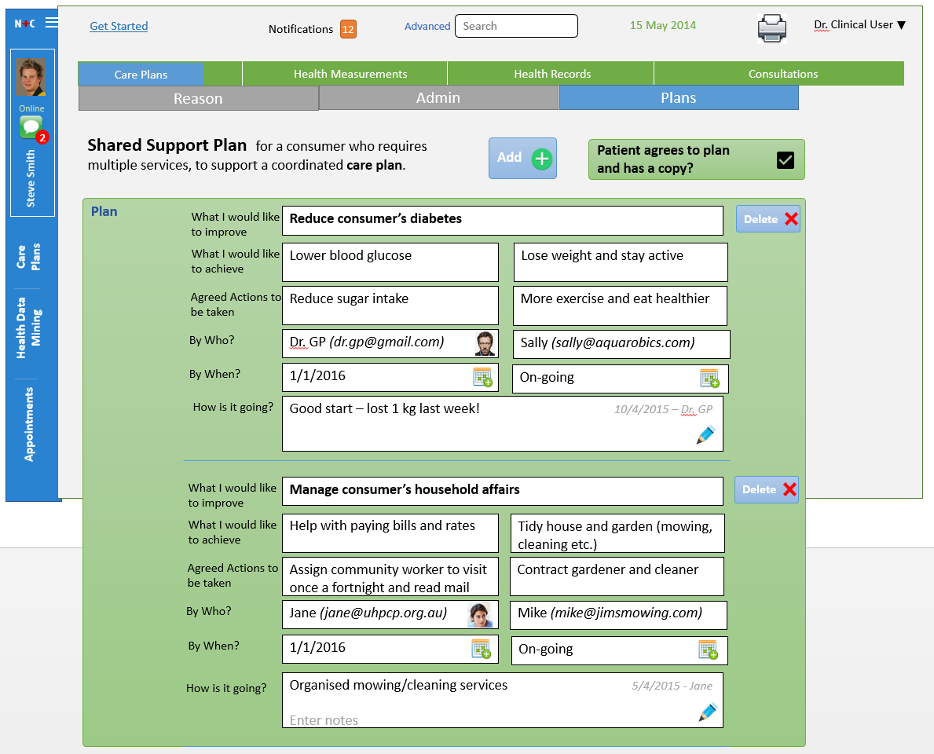

Figure 24 - Plans page of the care plan. Users can add and delete action steps, care team members, goals, specify progress notes, and reminders

Care plans can have 1 or more steps, which are added using the “Add” button on the top of the form. Clicking “Delete” on a specific care plan step will show a prompt “Are you sure you want to delete this care plan step?” before actually deleting it.

**By Who?**

* Both name and email address is entered in a separate pop-up window when the field is pressed.  
   
* Care plan editor can start typing the provider’s name, and it will auto-fill a provider within the organisation
* If a photo ID exists, this will be shown in the photo placeholder at the bottom. If the person is new, the placeholder icon stays as is and user can tap it to select a photo from their tablet / PC.

**How is it going?**

* This field opens another pop-up (when the  icon is pressed) that allows user to scroll though all progress notes and add their own at the top.
* Hitting enter after entering notes in the “Enter Notes” field adds the note with date ascribed to it.
* Each progress note is marked with date-time and author  
  

**By When?**

* Option to enter a specific date, or select “On-going”
* By default, “on-going” will cause system to email the care team member once a week to ask about updating progress
  + Example reminder text:   
    “Hi [Provider Name],   
    We have noticed that you have not made any progress notes for the care plan for your assigned client [Client First Name].  
    Please log into the care plan portal at [care plan portal URL] and add a few notes on this week’s progress.  
    Thanks,  
    NHC team”
* If a specific date is set, reminders are sent once a week up until the due date, and again 1 day just before the due date
* If the entered date is less than or equal to 1 week form the current date, then a reminder is not sent until the day before the due date
* No reminder frequency/scheduling function is provided, or is needed. The above auto-reminding schedule is sufficient (i.e. reminder once a week, and one day before due date)[2].
* No reminder is sent if the care team member for that specific Plan Step has made an entry in the Progress Notes for the current week
* Notifications settings for the care plan team members are not saved until user moves away from the care plan form.
* Notifications are not sent unless a care team member is specified.

### Care Plan remediations

**New Care plan pop-up**

Initial information is entered when first creating a new plan, which is visible form the new status bar (see below):





Figure 22 - The Reasons page of the care plan.

**Status bar**

The following UX screen remediations and new functionality are required for phase 2.

Please read the notes in the screen design below:



* Care coordinator to be displayed at the summary banner up the top
* Button to reassign care plan coordinator to the currently logged in user/provider if the assigned coordinator is different from logged in user/provider
* PDF button to print the details of the care plan in standard SCTT format (see below)
* See notes in the screen shot above for UI placement and descriptions

**PDF format**

The PDF format must follow the below format. Merge fields are surrounded with square brackets (“[ …]”).



## UC8A – Care Plan List

Providers can also see all care plans of all clients, and see basic summary information and the allocated care coordinator (provider). The list will be presented in a simple scrollable list (using simple swipe gestures to scroll).



* Providers (doctors and carers) can also see all care plans of all clients, and see basic summary information and the allocated care coordinator (provider). The list will be presented in a simple scrollable list (using simple swipe gestures to scroll).
* Status: Active, Inactive, Please Review (this requires the care coordinator to check the care plan and mark it “Active” again). Make sure **colour coding** is implemented
* Clicking on either the client’s name, the client’s photo will open the specific care plan (as described in section 9.10)
* Care plans are sorted in the following order:
  + Client Name
  + Care plan name
* Clicking on the doctor/coordinator name or photo will open their profile screen
* Screen title will include the organisation name (of the user/provider’s login)
* Only care plans visible from the organisation the provider belongs to

## UC9 – Provider details

This screen shows the profile of individual providers registered in the system. Note that ordinary “care team members” who are not registered on the system do not have a profile.



* The screen cannot be edited. It is read only
* The providers name, clinic address and name, phone email, DOB are all visible
* The provider’s care plan(s) that they have created (and as such are the “care plan coordinator” for) are listed.
  + Tapping the “Client Name” or the photo in each row of the table will take the user straight to the care plan and specific plan
  + Table is similar to that shown in section 8.10.1

## UC10 – Care team member portal

A care team member is a care provider that is part of a client’s care plan. They can be clinical and non-clinical service providers, and are identified by email and (optionally) mobile/office phone number.

The care team member portal exists to allow care team members to perform several functions:

1. add progress notes on care plans that they are a part of
2. manage their notification settings
3. access details about the client’s care plan and (allowable) parts of their health record

Care team members are categorised into two groups:

1. Existing providers in the NHC system. They log into the tablet /desktop portal to interact with their tasks/care plans.
2. External providers who do not have logins to NHC portal

For the category (2), the workflow is simplified to minimise disruption and reasons for non-compliance:

* The design of the care team member portal will be a mobile friendly screen design that can also render on larger screens. This is because this will be the predominant platform for accessing this portal for most care team members.
* Note that other care plan steps (“Plan”) are not displayed to keep things simple. Access to other plans may be introduced in subsequent releases.

When a care team member is invited to a care plan, the following will occur:

1. An email is sent to the care team member’s email address defined in the care plan (“By Who?”) containing a unique web link (with unique HTTP POST code) that allows them to see the care plan they are assigned.
2. Care team member clicks the link which opens the care team member portal for that specific client’s care plan. The portal will display:
   * The care plan reasons
   * The plan details and goal(s) related to the care team member
   * An editable field where the care team member can add progress notes and view previously entered ones
3. Care team member can enter the progress notes (“How is it going?”), and cal also view the allowable health record information about the patient

Every reminder sent to the care team member will contain a link (whether it is email, or in future, SMS message). The main thing is that care team member does not need to remember any passwords, usernames etc. All they need to do is click the unique URL link in the reminder emails and they get restricted access to the client’s health record and the care plan they are assigned as care team member.



## UC11 – Client portal

Clients can also access their health record – they can view:

* Health measurements recorded in their record
* Medications
* Progress notes (within their care plans) that they have made themselves (but not by other care team members)

The only the exceptions are the following:

1. Consultation notes
2. Progress notes (“How is it going?”) within the care plan made by other care team members and the care coordinator

The reason being is that notes made by clinical and non-clinical providers can often by honest and negative about the patient. In the interest of a good relationship between provider and client, these notes should be hidden from the client. However, care team members can see all the progress notes within a care plan.

The platform for this client portal should be a mobile or tablet app. The app should be responsive so that the one application can render cleanly on either platform.

Structure:

* Dashboard screen showing Patient details (only: full name, phone number, care coordinator centre – only enough to confirm user but not fully idetificable for security reasons)
  + Care plan(s): Details, personal progress notes, goals, objectives, list of care team members
  + Health record: Health measurements – both manual entry, and automate dthrough device integration
  + Communication: Send communications to (a) hosting organisation, and (b) all/specific care team members in a care plan



## UC12 –Health Record

Each client has a health record with several elements, as shown below. The health record is accessible from the client record when the client is selected from the client

When user clicks on “Health Record” on the patient file:

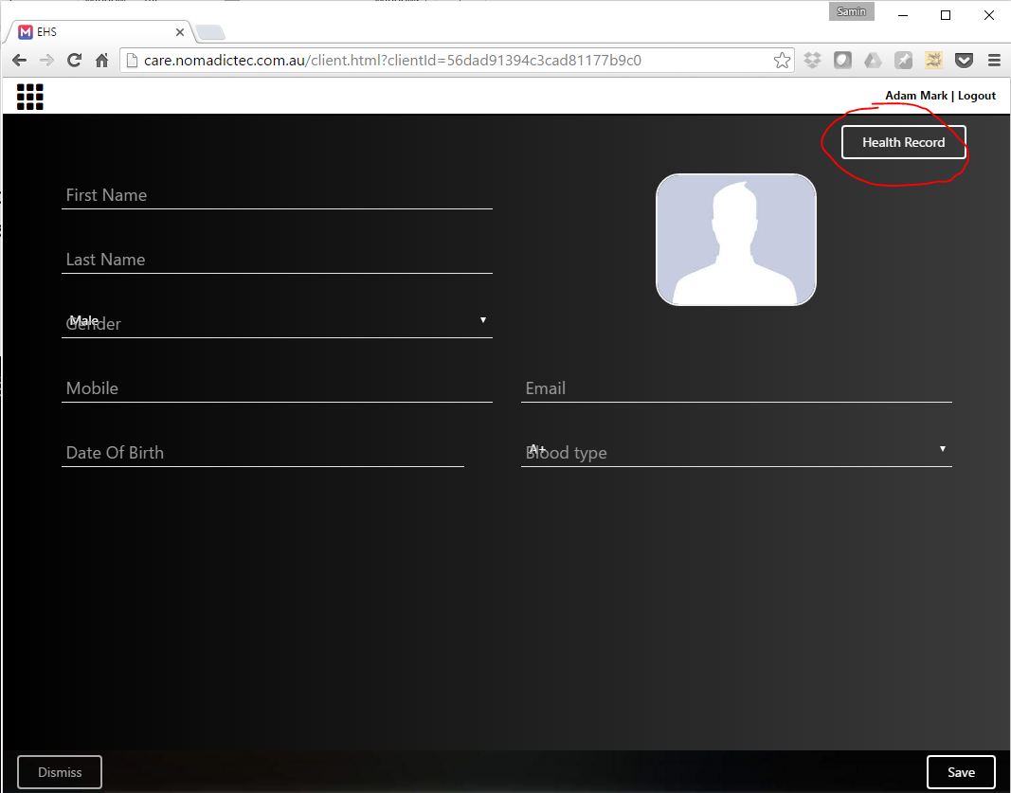

It will open the Health Record screen which shows multiple tabs and sub-sections for adding and reading all the different types of health records. The Care Plans are also accessible from this screen.

* Health Measurements
* Health Notes
* Consultation Notes
* Care Plans

In the following screen designs, rows that have text separated with “/” indicate that the data is selected from a drop-down list.

When user does swipe gesture on any screens, the screen will move between the sub-tabs (e.g. for “Health Notes”, it will transition between “Medications” to “Allergies” if user does right to left swipe gesture.

In the top banner, care plan status, age, gender, phone number and Suburb (locality) is shown. If user clicks on care plan status, he/she will be taken to the user’s care plan screen



* Clicking the hyperlink in the “Related Consultation” column will open the consultation note in a pop-up window

Example pop-up for adding Health Note (please use same format for other sub-tabs):











* Clicking the underlined text (hyperlink) in the “Notes” column will open up the original laboratory report (usually saved in text or PDF format) – again in a pop-up window





* Clicking the hyperlink in the “Document” column will open the document TXT, DOCX, DOC or PDF file in a pop-up window that user can scroll through

## UC13 – Health Measurement

The Nomadic Care application also allows clients and providers to add health measurements about the client. These health measurements are associated with the client’s health record.

There are three ways to add a health measurement:

1. Manually from provider portal: A simple dialog/form that allows providers to add a measurement on behalf of the client by typing in the value and the specific type of measurement. Accessed from the client’s health record
2. Manually from the client portal: The client themselves can make a manual entry from their client portal (app / web).
3. Automatically from measurement device from client portal: The client portal will be equipped with functionality to integrate with several health measurement devices (e.g. fitbit aria, fitibit activity tracker, Moto 360 smart watch, Bluetooth pulse oximeter). These devices are integrated via Bluetooth, or via wifi hotspots.

### Manual entry from provider portal

Option to add health measurement from the client health record. This is accessed when the client is selected, and the user (provider) clicks “Health Record”, where “Health Measurement” is available as an option.

First, user clicks “Health Record” from the client file:



Then user clicks “Health Measurement” tab, where all the various measurements are available I sub-tabs:



* User can select unit – kg, lb (pounds), or BMI. The part with label “Unit” is a toggle widget
* Height is an optional field
* “Notes” is an optional field
* If BMI (body mass index, which is weight divided by height in metres squared – BMI = W / h^2) selected, the BMI is calculated based on the last height value entered. Example:
  + Measurement 1: W = 89 kg, H = 1.70 m (170 cm) -> BMI = 89 / 1.7 ^ 2 = **30.8**
  + Measurement 2: W = 91 kg, H = (Not entered) -> BMI = 91 / 1.7 ^ 2 = **31.5** (use last height of 1.7 m from measurement 1)
  + Measurement 3: W = 94 kg, H = 1.71 m (171 cm) -> BMI = 94 / 1.71 ^ 2 = **32.2**
  + The above rule only applies for patients age 22 years and above. For patients 22 and below, if height is not entered then the BMI value is not available if height not entered
* When user clicks on a part of the graph, the “Graph Selection” section will show the values of that weight/BMI











To add a value, a pop-up will appear and allow the user to enter values.

Note that device measurements will be taken from a separate, specific application for device integrations – which can be used by clients (patients) or a care giver / provider associated to a patient.

Below is an example



Figure 25 - Example measurement dialog box (for weight / BMI entry)

* User can specify units for weight (kg or lb)
* Height is optional, and can be entered in cm or feet/inches

## UC14 – Health Analytics

This screen is accessible from the main Health Record page, as with the UC12, Health Record:



### Correlation Graphs

Once in the Health Record screen, user taps the “Analytics” tab, and can choose from predefined analytics screens:

* Diabetes
* Cardiac Health

New analytics engines will be defined in future, but user cannot define them himself/herself (the system designer will create them).



* The graphs can be scrolled using swipe gesture, and zoomed in and out (scale change) using pinch gesture. Some example libraries to consider
  + <http://gionkunz.github.io/chartist-js/>
  + More example libraries here: <http://www.learningjquery.com/2015/03/15-top-jquery-chart-plugins-for-developers>
* If “I” is tapped, the below pop-up will open explaining the analytics



* Clicking “PDF” will print the graphs and notes (as seen on the screen) onto a PDF file for saving or printing

### Trace Graphs

In addition, users can right click any health record or measurement, and then create a trace of related records and measurements. The system will generate a graph showing all related health records and health measurements that were recorded around the same time, or which are connected somehow (e.g. a medication prescribed after consultation, etc.)

In below example, let’s say user right-clicks (for desktop) or long presses (for tablet/mobile app) the “Oxycontin” medication, and selects “Create Trace”:



*\* User can right click on desktop, or long press the medication “Oxycontin”, which will open*

*context menu below the screen for “Create Trace”. The row that was selected will be highlighted so user knows which one they selected*



As you can see, the Oxycontin drug:

* Relates to a Consultation done at the same time as prescribing
* Diagnosis made on the same day, that was related to the consultation
* Measurement of increased heart rate made on following day

These connections can only exist if they occur from 0 – 20 days of each other. So, if increased heart rate was measured in 1/7/2014, the connection will not be shown.

* Clicking “PDF” will print the graphs and notes (as seen on the screen) onto a PDF file for saving or printing
* User can “Add Note…”. Once added, it can be edited later on simply by clicking the box again

## UC15 – Consultation Notes

Consultation notes is accessed from the “Health Record” screen, accessible as described above:



The consultation notes screen can be used to store simple notes about any consultations the provider has with the client. The following information is captured:

* **Clinical Reason** – This is a drop down list, with option to specify “Other” and free text field.
* **History** (additional notes to be captured in addition to other historical data pre-existing in the NHC system, such as prior consultation notes, measurements, health record data etc.)
* **Examination** – What the notes are from discussing the client’s issues and possible candidate treatment plans
* **Treatment** – The settled treatment plan that the patient has been prescribed

When “New Consultation” is added with a large pop-up screen with all the above fields where user can type in text.



# Non-Functional Requirements

## Usability Requirements

Describe what the system usability requirements are. What responsiveness is needed? What UI layout is the best one for the business requirements and type of customers?

| **Usability Criterion** | **Specific UI requirements** |
| --- | --- |
| System status visibility and location – how system informs user about what is going on |  |
| UI alignment with user’s environment |  |
| User control and freedom (e.g. ability to exit an operation whenever needed) |  |
| Consistency and standards – any terminology and UI standards required |  |
| Error prevention – e.g. data validation, accidental clicks (e.g. clicking “Cancel” before saving) |  |
| Intuitiveness – use icons and recognisable UI widgets to reduce the need for remembering |  |
| Flexibility and efficiency of use – “accelerators” (e.g. hotkeys) for expert users, and standard features for novice users |  |
| Aesthetics – minimalist and simplistic design |  |
| Error recovery – ability of users to recover from an error |  |
| In-application help and documentation – such as: help files, tooltips and wizards |  |

## Hardware Transition Considerations

Describes the change from current hardware requirements to future hardware requirements as a result of implementing the system outlined in this FDS.

|  |  |  |
| --- | --- | --- |
| Feature | Current  (before implementing this FDS) | Future  (after implementing this FDS) |
| **Server platform** |  |  |
| **Operating System** |  |  |
| **RAM** |  |  |
| **Storage** |  |  |
| **Power** |  |  |

## Software Transition Considerations

Describes the change in software platform requirements from current to future state as a result of implementing the system outlined in this FDS.

| Feature | Current  (before implementing this FDS) | Future  (after implementing this FDS) |
| --- | --- | --- |
| **Web Server** |  |  |
| **Application Server 1** |  |  |
| **Application Server 2** |  |  |
| **Database (e.g. licenses, versions)** |  |  |

## Conversion Requirements

What data conversions are required for the proposed system to integrate with other systems.

| Conversion requirements | Affected system(s) | Integration requirements (after implementing this FDS) |
| --- | --- | --- |
| **Data table / object 1** | (e.g.) PID table | Need to transform to … schema |
|  |  |  |
|  |  |  |
|  |  |  |

## Security Requirements

List all security requirements where relevant.

| **Security Aspect** | **Technical Requirement** | **Traceability (reference to Business requirement)** |
| --- | --- | --- |
| **Code security** (e.g. obfuscation for Android APKs) |  |  |
| **Authentication** (e.g. SAML tokens, oAuth-1/2) |  |  |
| **Data encryption** (e.g. 128/256-bit AES encryption for stored data either locally or on servers) |  |  |
| **Web Service security** (e.g. using SSL encryption with RESTful, etc.) |  |  |
| **Code QA** (e.g. preventing SQL injection) |  |  |
| **Malicious attack prevention** (e.g. DoS/DDoS) |  |  |
| **Disaster Recovery** (e.g. failover) |  |  |

Table 4 Security requirements

## Logging and Audit Requirements

List all the data that needs to be logged and audited.

| ID | Data item | Log / Audit |
| --- | --- | --- |
| 1 |  | [Log / Audit / Both] |
| 2 |  |  |
| 3 |  |  |

## Performance

The system performance requirements specific to the delivered functionality are listed below.

### Load

|  |  |
| --- | --- |
| **Required maximum concurrent users** |  |
| **Data constancy with increased users** |  |
| **Screen load time (response time) – even over low bandwidth** |  |
| **Sustainability of high concurrent users** |  |
| **Sustainability of continuous usage by 1 user** |  |

### Volume

|  |  |
| --- | --- |
| **Data volume requirements (calculated per user/patient and/or in total)** |  |
| **Allow for large number of transactions (total per day and concurrently)** |  |
| **Sustainability of high concurrent users** |  |
| **Sustainability of continuous usage by 1 user** |  |

### Stress

|  |  |
| --- | --- |
| **Required tolerance for increased number of users and data** |  |
| **Error tolerance for memory leakage, overwrites, pointers etc.)** |  |

# Acceptance Criteria

This section is the reference point for checking that the implementation has fulfilled the FDS.

The lead developer and solution architect/BA must meet after system implementation and conduct a internal UAT. This table will be used as the focal point to pass the internal UAT.

## List

|  |  |  |  |
| --- | --- | --- | --- |
| **ID** | **Criteria** | **Reference** | **Status** |
| 1 |  |  | [Fulfilled / Not fulfilled (with reason)] |
| 2 |  |  |  |
| 3 |  |  |  |
| 4 |  |  |  |
| 5 |  |  |  |
| 6 |  |  |  |

## Analysis Checklist

Standard checklist for all projects that must be performed at UAT.

| **Category** | **Considered** |
| --- | --- |
| Have existing requirements that may conflict with this change identified? |  |
| Are the consequences of not making the change defined? |  |
| What are the possible adverse or side effects of making this change? |  |
| Is there a potential performance impact? |  |
| Does this affect privacy, security or patient safety? |  |
| Is this change feasible within the technical constraints |  |
| Are new staff skills required to cope with this change? |  |
| Do we need any new tools? |  |
| Do we need to prototype and get user user acceptance before the full implementation? |  |
| Do these changes increase the unit cost of the product or impose additional costs to the user by way of labour, license or hardware? |  |
| Does this change affect marketing, CSD and Training process? |  |
| Does it impose additional changes to external interfaces? |  |
| Does this change invalidate any other functionality or alter existing functionality? |  |
| Do existing Test Scripts need altering? |  |
| Do help files other training materials need to be altered? |  |
| Are other applications, utilities are affected by this change? |  |

# Appendix

## Appendix A:

## Issues Log

|  |  |  |  |  |  |  |
| --- | --- | --- | --- | --- | --- | --- |
| **Issue No.** | **Description** | **Raised By** | **Date** | **Mitigation** | **Responsibility / Target Date** | **Status** |
|  |  |  |  |  |  |  |

This page is left blank intentionally

1. CAMed is an XML/XSD/WSDL file editor: <http://sourceforge.net/projects/camprocessor/>
2. The need for complex reminder scheduling is not a priority and most users expect the system to manage the reminders rather than specifying detailed schedules